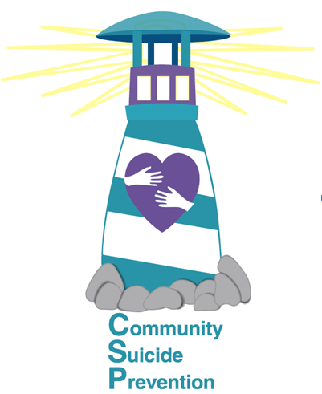
Community Suicide Prevention
Community Meeting Minutes from
June 5, 2025

In attendance
In person:
Lisa Elkins Timalee Geisler Christine Adams
Rick Croft Kaitlyn Browning Brittany Ohman
Jessica Earhart

Zoom:
Tina Ricks Seina Canales RaeAnne Buerstatte
Nicki Hope Melina Kettles Faith Dixon
Dan Bruderer Matt Queen Bonny Jennings
Russ Wheatley Tina Wheatley

Rick Croft welcomed attendees and brought the meeting to order. He introduced Brittany Ohman and Jessica Earhart, advisors for the Rigby High School Hope Squad, as the guest speakers.

Please see the attached PowerPoint presentation for purpose and activities of the Hope Squad at Rigby High School.

Matt Queen asked about ASIST trainings near Pocatello.

CSP is participating in six local parades this year. See us at the Rigby Stampede Days Parade on Saturday, June 21. The next parade is the Idaho Falls Independence Day Parade on Friday, July 4th.

Rick reminded the group of the Suicide Prevention Conference on September 19 in Idaho Falls.

Community Youth in Action is sponsoring three Block Parties this Summer. The first one is June 11 at Central Park. There will be one on July 16 at Esquire Park and one on July 23 at Kate Curly Park. Timalee will attend the July 16 party and provide suicide prevention information. The purpose of the block parties is to connect low-income families with community resources.

Rick concluded the meeting and excused the participants.

Next CSP Community Meeting is scheduled for
Thursday, July 10 at Noon
at Eastern Idaho Public Health, 1250 Hollipark, Idaho Falls.

