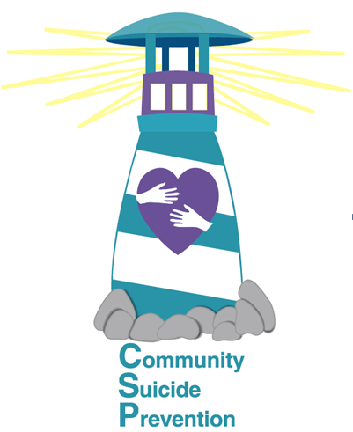
Community Suicide Prevention
Meeting Minutes from July 10, 2025

In attendance:
In person:
Christine Adams Timalee Geisler Lisa Elkins Lynn Wade
Andrea Hamilton Eric Adams Sheila Murdock

Via Zoom:
Kiyanna Cortes – IDHW Iris Cruz – IDHW, Case Manger
Chelsey Hale – part-time clinician at Tueller & counselor at Thunder Ridge HS
Jennifer Tuck – CASA Debra Lively - CASA
Melinda Kettles Jan Eastman Melissa Schrade
McKayla Todd – outpatient at Stewards of Recovery
Liz Behrend –Southeast Idaho Public Health

Excused:
Tina Wheatley Russ Wheatley Rick Croft
Brandie Weaver Bonny Jennings

Christine welcomed attendees and asked for introductions.

Christine excused Rick who is representing CSP at CIT training at Madison Health in Rexburg.

Melissa Schrade has organized a suicide prevention fundraiser on Friday, July 11, 2025, at 7 pm at the Leavitt Center in Pocatello. It is free to attend but accepting donations for Community Suicide Prevention. Different artists are coming together to share their talents. Baked food sale, as well. Donated baked goods can be delivered upon arrival at the event. The headliner act is Lane Bowen. He is well known in the Pocatello area. Board members wear black polo shirts.

Derek Emrey with the Foundations Program was the guest speaker. He works as a peer support person. Amy Fluckinger is the case manager.

Foundations is a comprehensive program that offers a combination of therapy, counseling, support groups, and skill-building workshops to address the unique needs of each individual. Through a combination of evidence-based practices and personalized care, Foundations strive to help to help clients not only overcome their challenges, but also to develop the resilience and self-esteem necessary to lead fulfilling lives. Through a combination of education, support, and mentorship, Foundations aim to equip clients with the confidence and skills needed to succeed.

In addition to supporting individuals with substance use challenges, mental health concerns, disordered eating, and a history of sexual/violent offenses, Foundations also work to address underlying issues that contribute to these struggles. Through a holistic approach to treatment, Foundations strive to help clients heal from past traumas, develop healthy coping mechanisms, and build strong support systems.

The Foundations Program offers Safe and Restorative Housing. The homes offer a safe and supportive environment for both men and women, ensuring treatment services. Men’s and women’s homes are available in Twin Falls and Idaho Falls. Foster care homes are available in Shelley. Idaho Falls also has family homes. A residential facility will eventually open in Filer, and they are looking for property in Pocatello.

The Foundations Program also leverages cutting-edge technology to empower clients in skill-building, workforce development, personalized treatment, and telehealth services. Foundations commitment is to provide innovative solutions that cater to individual needs.

Foundations is funded through Magellan and Medicaid for safe and sober housing.
Foundations opened their doors in January of 2025. For more information on the Foundations Program, visit www.thefoundationsprogram.org, call 208-329-6921, or e-mail info@thefoundationsprogram.org or admissions@thefoundationsprogram.org

The CSP goals for 2025 were reviewed. The first goal is to offer 12 trainings per year and to add trainers. RaeAnne and Katie are being trained and Sheila with CSP has offered six trainings. Eastern Idaho Public Health has held one Mental Health First Aid training, and Madison Cares has held three trainings. Two additional trainings have been requested in August.

The second goal was to create a document that provided information on Mental Health providers, what licensures mean, etc. Rick and Timalee have been working on this document and have a draft ready to be approved by the Executive Board. Once approved, the document will be housed on the CSP website in a PDF version. This document can also be shared with agencies for their website. This document should be released in August.

The third goal is to add a memorial bench in an additional community. The City of St. Anthony has been chosen. The city has a space chosen for the bench. The artist has been notified, and we hope to dedicate the bench in September. The date will be announced soon.

Next CSP Community Meeting is scheduled for
Thursday, August 7 at Noon
at Eastern Idaho Public Health, 1250 Hollipark, Idaho Falls.

